NMR and UV studies of 3’-S-phosphorothiolate modified DNA in a DNA:RNA hybrid dodecamer duplex; Implications for antisense drug design
Andrew P.G. Beevers,ª Kevin J. Fettes^{b}, Ghalia Sabbagh^{b} , Fatima K. Muradª, John R.P. Arnold^{c}, Richard Cosstick^{b} and Julie Fisher^{*a}
Supplementary Information
S1. Chemical shift assignments for (2) the non-modified DNA:RNA hybridª
 | Chemical shifts of protons/ppm
Residue | H1’ | H2’ | H2’’ | H3’ | H4’ | H5/Me/H2 | H6/H8 | Imino* | Amino*
C1 | 5.94 | 2.57 | 2.67 | 4.68 | 4.17 | 6.07 | 8.04 | -
C2 | 6.07 | 2.42 | 2.71 | 4.80 | 4.33 | 5.69 | 7.81 | - | 7.08, 8.70
T3 | 6.03 | 2.36 | 2.72 | 4.96 | 4.28 | 1.64 | 7.63 | 13.31 | -
A4 | 6.03 | 2.63 | 2.86 | 5.07 | 4.43 | 6.50 | 8.15 | -
A5 | 5.98 | 2.66 | 2.80 | 5.03 | 4.45 | 7.02 | 7.96 | -
A6 | 6.13 | 2.54 | 2.82 | 4.86 | 4.43 | 7.63 | 7.84 | -
T7 | 5.92 | 2.11 | 2.58 | 4.79 | 4.24 | 1.19 | 7.14 | 13.85 | -
T8 | 6.16 | 2.24 | 2.68 | 4.90 | 4.28 | 1.51 | 7.50 | 13.82 | -
T9 | 6.07 | 2.40 | 2.64 | 4.97 | 4.24 | 1.66 | 7.48 | 13.23 | -
G10 | 5.91 | 2.55 | 2.64 | 4.92 | 4.39 | - | 7.68 | 12.24
C11 | 6.04 | 2.28 | 2.56 | 4.74 | 4.29 | 5.18 | 7.45 | - | 6.48, 8.33
C12 | 6.17 | 2.13 | 2.29 | 4.49 | 4.05 | 5.42 | 7.51 | -
G13 | 5.56 | 4.81 | - | 4.27, 4.51 |  | - | 7.89
G14 | 5.80 | 4.58 | - | 4.49 |  | - | 7.52 | 13.12
C15 | 5.41 | 4.57 | - | 4.43, 4.50 |  | 5.28 | 7.61 | - | 6.79, 8.22
A16 | 5.82 | 4.61 | - | 4.71 |  | 6.80 | 8.00 | -
A17 | 5.81 | 4.61 | - |  |  | 7.33 | 7.93 | -
A18 | 5.82 | 4.52 | - | 4.82 |  | 7.77 | 7.91 | -
U19 | 5.37 | 4.39 | - |  |  | 5.03 | 7.61 | 13.92 | -
U20 | 5.63 | 4.42 | - | 4.47 |  | 5.55 | 8.10 | 13.93 | -
U21 | 5.64 | 4.55 | - | 4.64 |  | 5.70 | 8.15 | 13.26 | -
A22 | 5.99 | 4.63 | - |  |  | 6.85 | 8.17 | -
G23 | 5.46 | 4.39 | - | 4.44 |  | - | 7.19 | 12.99
G24 | 5.83 | 4.04 | - | 4.21 |  | - | 7.30

- Shifts were measured at 25 ºC for sample in 10 mM phosphate buffer, 100 mM NaC, D₂O solution. Shifts were referenced to residual HOD peak at 4.8 ppm.
* Exchangeable proton shifts were measured at 15 ºC.

S2. Chemical shift assignments for (1) the 3’-S-phosphorothiolate modified DNA:RNA hybridª

 | Chemical shifts of protons/ppm
Residue | H1’ | H2’ | H2’’ | H3’ | H4’ | H5/Me/H2 | H6/H8 | Imino* | Amino*
C1 | 5.96 | 2.58 | 2.66 | 4.68 | 4.18 | 6.08 | 8.06 | -
C2 | 6.06 | 2.42 | 2.70 | 4.79 | 4.30 | 5.69 | 7.81 | - | 7.07, 8.68
T3 | 6.02 | 2.36 | 2.70 | 4.95 | 4.27 | 1.63 | 7.63 | 13.34 | -
A4 | 6.03 | 2.62 | 2.84 | 5.06 | 4.41 | 6.49 | 8.14 | -
A5 | 5.96 | 2.67 | 2.77 | 5.01 | 4.43 | 7.00 | 7.95 | -
A6 | 6.12 | 2.56 | 2.79 | 4.80 | 4.40 | 7.61 | 7.82 | -
T7 | 5.86 | 2.25 | 2.59 | 4.72 | 4.22 | 1.19 | 7.18 | 13.82 | -
T8 | 5.97 | 2.47 | 2.68 | 3.61 | 4.14 | 1.53 | 7.58 | 13.84 | -
T9 | 6.07 | 2.48 | 2.66 | 4.93 | 4.33 | 1.64 | 7.81 | 13.18 | -
G10 | 5.94 | 2.54 | 2.63 | 4.88 | 4.36 | - | 7.73 | 12.30
C11 | 6.02 | 2.28 | 2.55 | 4.73 | 4.27 | 5.19 | 7.47 | - | 6.56, 8.40
C12 | 6.16 | 2.13 | 2.29 | 4.48 | 4.04 | 5.42 | 7.52 | -
G13 | 5.63 | 4.84 | - |  |  | - | 7.94
G14 | 5.83 | 4.55 | - | 4.50 |  | - | 7.56 | 13.18
C15 | 5.45 | 4.58 | - |  |  | 5.28 | 7.65 | - | 6.79, 8.33
A16 | 5.83 | 4.61 | - | 4.52 |  | 6.81 | 7.97 | -
A17 | 5.75 | 4.58 | - | 4.52, 4.69 |  | 7.22 | 7.86 | -
A18 | 5.80 | 4.51 | - |  |  | 7.69 | 7.86 | -
U19 | 5.34 | 4.37 | - |  |  | 5.00 | 7.58 | 13.89 | -
U20 | 5.61 | 4.39 | - |  |  | 5.52 | 8.08 | 13.90 | -
U21 | 5.63 | 4.53 | - |  |  | 5.69 | 8.14 | 13.25 | -
A22 | 5.98 | 4.61 | - | 4.73 |  | 6.83 | 8.16 | -
G23 | 5.46 | 4.38 | - | 4.42 |  | - | 7.18 | 13.01
G24 | 5.82 | 4.02 | - | 4.20 |  | - | 7.30
- Shifts were measured at 25 ºC for sample in 10 mM phosphate buffer, 100 mM NaC, D₂O solution. Shifts were referenced to residual HOD peak at 4.8 ppm.
* Exchangeable proton shifts were measured at 15 ºC.

S3. Contour plots of the H1’-H2’/H2” region of the TOCSY (A) and NOESY (B) spectra recorded for (1) and (2).
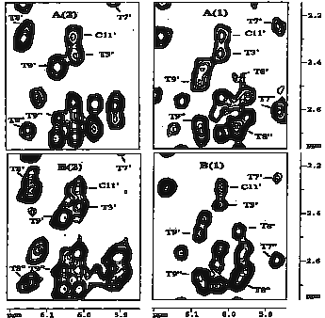

S4. Sections of the NOESY spectrum recorded for (2) (left hand side) and (1) (right hand side) with cross-sections illustrating the relative intensities of the H2 to H1’ nOe connections.
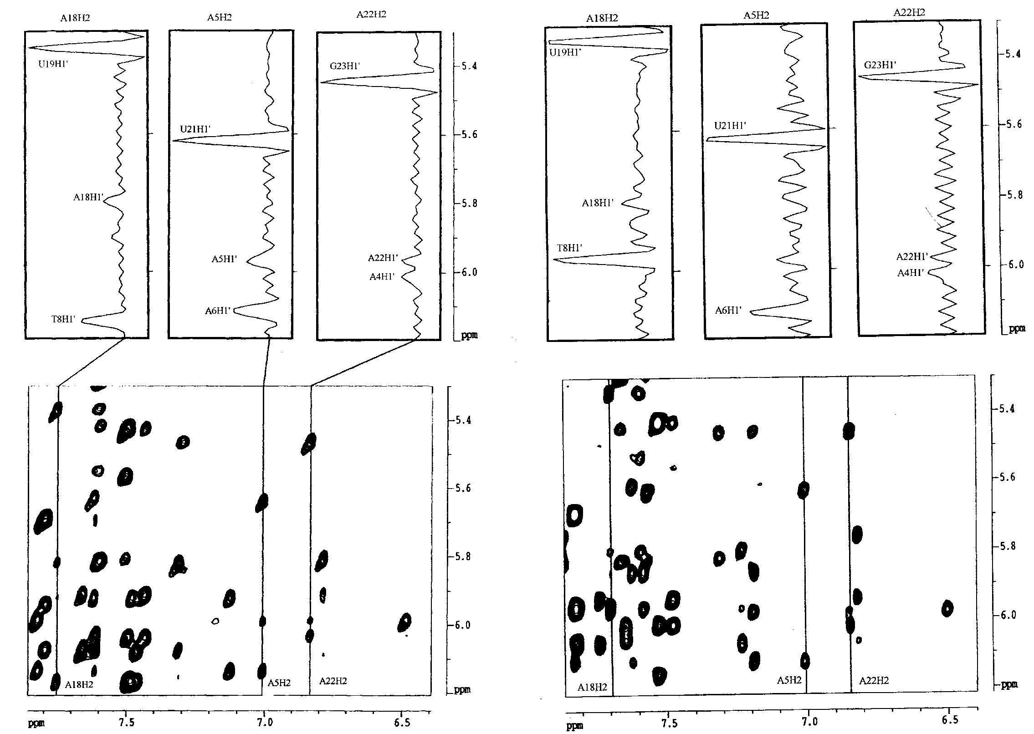

S5. Sections of the PE-COSY spectrum recorded for (2) (A) and (1) (B) containing the H1’-H2’, and H1’-H2” connections. The boxed region in (B) indicates the chemical shift T₈H2’
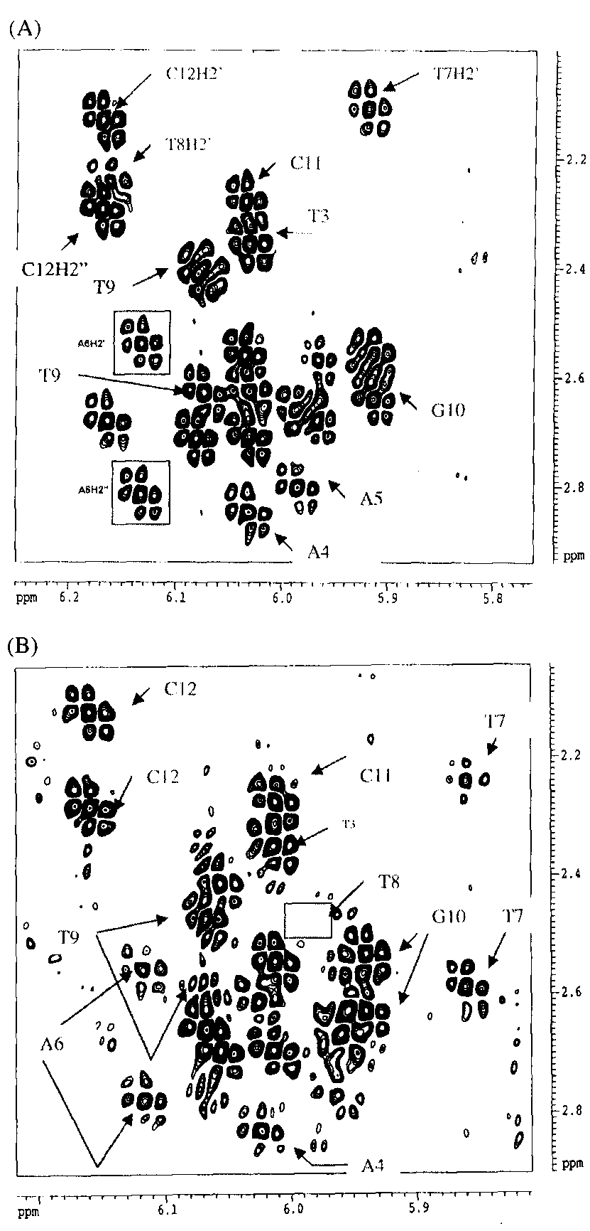
.

S6. UV thermal melting curves for the natural hybrid (2) and the modified hybrid (1).
S7. UV thermal melting temperatures, and temperature differences.
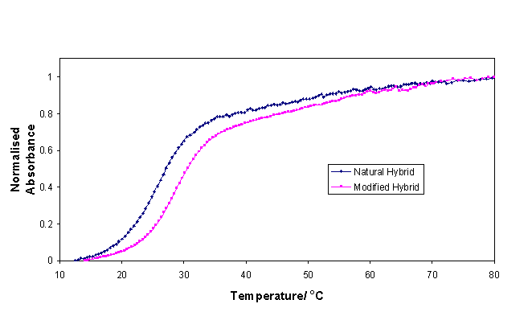
Entry No | Duplex | Tm, ºC | ΔTm/mod, ºC
2 | d(CCTAAATTTGCC)  r(GGAUUUAAACGG) | 25.2 | -
3 | d(CCTAAATTTGCC)  r(GGAUUUAAACGG) | 26.5 | 1.3
1 | d(CCTAAATTTGCC)  r(GGAUUUAAACGG) | 26.8 | 1.6
4 | d(CCTAAATTTGCC)  r(GGAUUUAAACGG) | 26.5 | 1.3
5 | d(CCTAAATTTGCC)  r(GGAUUUAAACGG) | 28.8 | 1.8
6 | d(CCTAAATTTGCC)  r(GGAUUUAAACGG) | 28.8 | 1.8
7 | d(CCTAAATTTGCC)  r(GGAUUUAAACGG) | 29.2 | 2.0

T – indicates the residue to which the 3’-S-link is attached.

